Technical Report

(LMS Project)

# Project Overview

The SJ Academy Learning Management System (LMS) is a web-based application designed to facilitate the management and delivery of educational resources and activities for students, teachers, and academic officers. The system provides a centralized platform for teachers to upload assignments, notes, and other learning materials, while students can access these resources, submit their work, and track their progress. Academic officers have administrative privileges to oversee the overall system and manage user accounts.

The LMS aims to streamline the educational process by providing a user-friendly interface for all stakeholders, enabling seamless communication and collaboration between students, teachers, and academic officers. The system is built using a combination of front-end technologies (HTML, CSS, JavaScript) and back-end technologies (PHP, MySQL).

# Technologies Used

## Frontend

### HTML (Hypertext Markup Language)

HTML is the standard markup language for creating web pages. It defines the structure and content of a web page using different elements and tags. In the SJ Academy LMS, HTML is used to create the user interface and provide the overall layout of the application.

### CSS(Cascading Style Sheet)

CSS is a style sheet language used for describing the presentation and styling of web pages. In the LMS project, CSS is used to enhance the visual appearance of the user interface, including colors, fonts, layouts, and responsive design.

### JavaScript

JavaScript is a programming language used to add interactivity and dynamic behavior to web pages. In the SJ Academy LMS, JavaScript is used for client-side validation, handling user interactions, and enhancing the overall user experience.

## Backend

### PHP (Hypertext Preprocessor)

PHP is a server-side scripting language widely used for web development. In the SJ Academy LMS, PHP is employed for handling server-side operations, such as processing user input, interacting with the database, and generating dynamic content.

## Database

### MySQL

MySQL is an open-source relational database management system (RDBMS) used for storing and retrieving data in the LMS project. It is responsible for managing user accounts, assignments, notes, and other relevant data.

# ERD Diagram

An Entity-Relationship Diagram (ERD) is a graphical representation of the logical structure of a database. It depicts the relationships between different entities (tables) within the database, as well as the attributes (columns) and constraints associated with each entity. ERDs are an essential part of database design and help in visualizing the organization of data before implementing the actual database.

ERDs are essential for database design as they help in organizing data logically, identifying relationships between entities, and ensuring data integrity and consistency. They serve as a blueprint for creating the physical database schema and are particularly useful in complex database systems with multiple entities and relationships.

In the below ERD for SJ Academy LMS ERD is given.

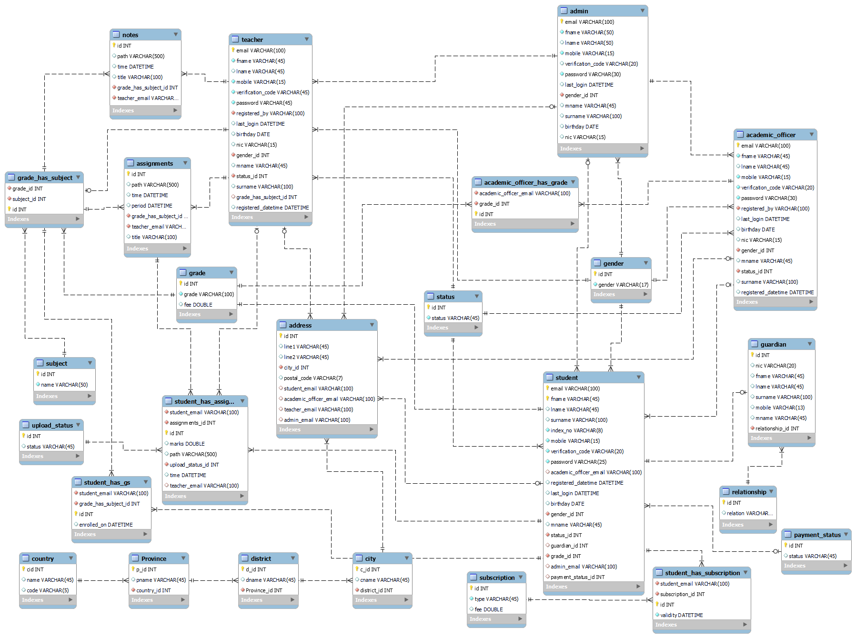

# Program Features

## File Structure

The project follows a standard file structure, with separate directories for HTML files, CSS stylesheets, JavaScript files, and PHP scripts. Additionally, there is a directory for storing uploaded files (assignments, notes, etc.).

## User Authentication and Authorization

The LMS implements a robust user authentication and authorization mechanism to ensure secure access to the system's functionalities. Users (students, teachers, academic officers, and administrators) are required to log in with their credentials (email and password) before accessing the system.

The authentication process is handled in the header.php file, which checks if a user session is active and redirects the user accordingly. For example, if a teacher is logged in, the system will display the teacher-specific navigation menu and functionality

Here's a code snippet from the **header.php and signinprocess** file, which includes the user authentication logic:

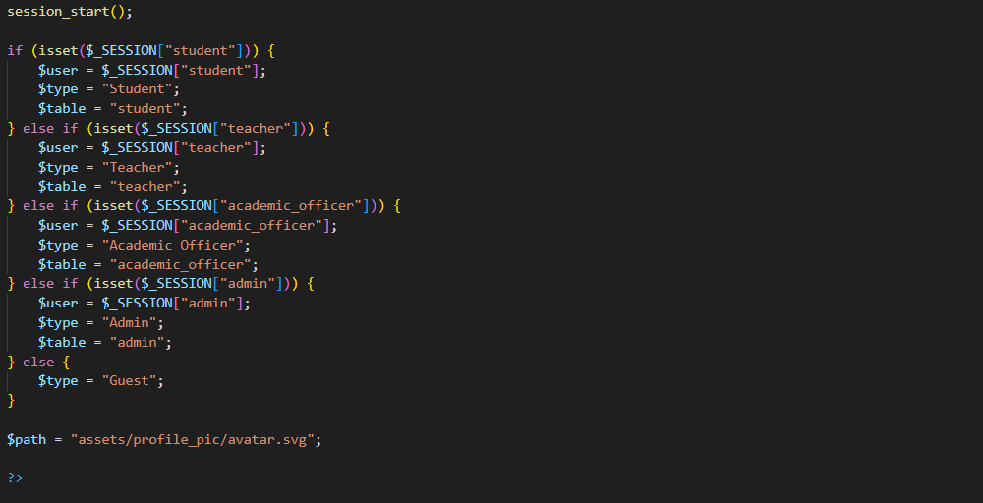

Login Outputs are looks like this.



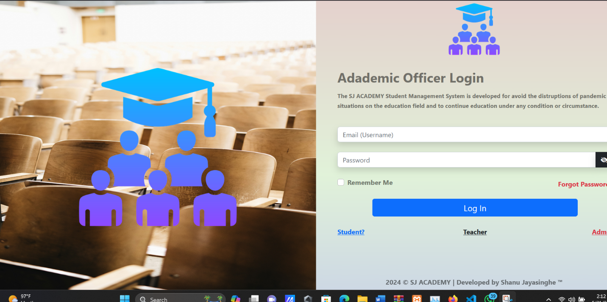





After successful authentication, the user's information is stored in the session, and relevant cookies are set based on the "Remember Me" option. This approach ensures that only authorized users can access the system's features and resources.

### Assignment Management

The LMS provides functionality for teachers to create and manage assignments for their respective courses. Students can download the assignment files, submit their work, and view their grades.

Here's a code snippet from the **addAssignments.php** file, which allows teachers to upload and release new assignments:

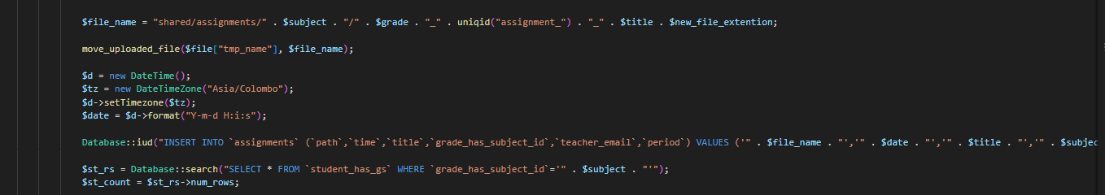

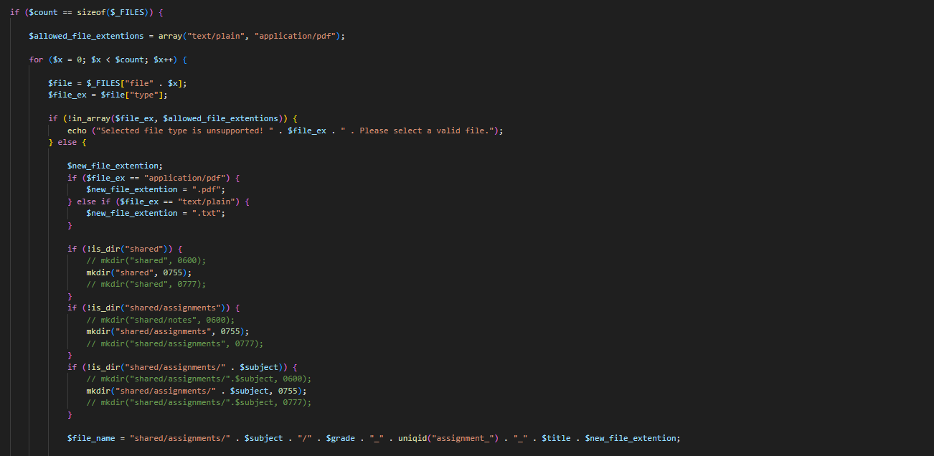

The output will be look like this

The **assignments.php** file displays a list of assignments for teachers, students, and academic officers, allowing them to download assignment files, submit work (for students), and view submissions and grades (for teachers and academic officers)

### Note Management

Similar to assignments, the LMS allows teachers to upload and share notes with their students. Students can access and download these notes for their respective courses.

Here's a code snippet from the **addNotes.php** file, which enables teachers to upload new notes:

Same like the previous one same logic is implemented for this operation (add assingment process)

The output will look like this

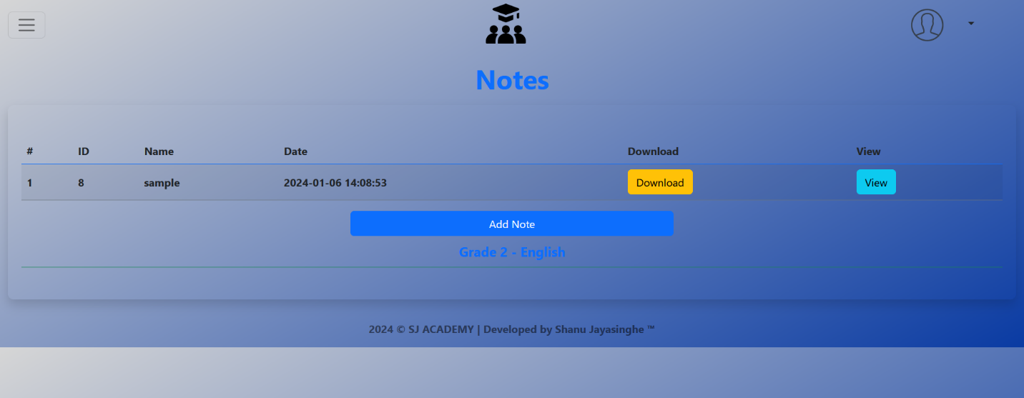

### Administration Panel

The LMS includes an administration panel accessible only to authorized administrators. This panel, represented by the adminPanel.php file, provides an overview of the system's usage statistics, such as the number of registered students, teachers, academic officers, and assignments.

Here's a code snippet from the adminPanel.php file, which displays various statistics and recent user registrations:







These are only some code snippets. The output will look like this.

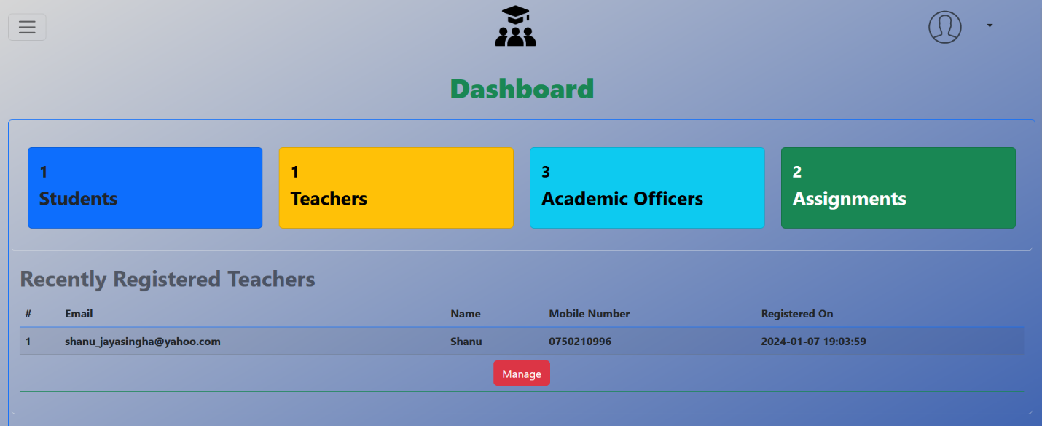

The administration panel also provides options to manage users (teachers, students, academic officers) by navigating to the respective management pages (manageTeachers.php, manageStudents.php, manageAcademics.php).

The administration panel serves as a central hub for administrators to monitor the system's usage, track user registrations, and access user management functionalities, ensuring effective oversight and maintenance of the LMS.

**Conclusion**

The SJ Academy Learning Management System is a comprehensive web-based application designed to streamline the educational process by providing a centralized platform for students, teachers, and academic officers. The system leverages a combination of front-end technologies (HTML, CSS, and JavaScript) and back-end technologies (PHP and MySQL) to deliver a user-friendly and efficient learning environment.

The LMS offers a range of features that cater to the needs of different user roles. Teachers can create and manage assignments, upload notes, and track student submissions. Students can access course materials, submit their work, and monitor their progress. Academic officers have administrative privileges to oversee the overall system and manage user accounts.

The project's code snippets showcase the implementation of various functionalities, such as user authentication and authorization, assignment management, note management, and an administration panel for system analytics. The use of PHP and MySQL ensures secure data handling, efficient storage, and retrieval of information.

The provided Entity-Relationship Diagram (ERD) serves as a visual representation of the database structure, depicting the relationships between different entities and their attributes. It acts as a blueprint for creating the physical database schema and ensuring data integrity and consistency.

Overall, the SJ Academy Learning Management System demonstrates a well-designed and robust solution that addresses the challenges of modern educational institutions. By leveraging web technologies and a structured database design, the system facilitates effective collaboration, communication, and knowledge sharing among students, teachers, and academic officers.

Looking ahead, the LMS project can be further extended and enhanced with additional features, such as real-time communication tools, integrated grading systems, and learning analytics. Continuous improvement and adaptation to emerging technologies and educational trends will be crucial to maintaining the system's relevance and meeting the evolving needs of the academic community.